# Title of the Paper

1st Author*1, 2nd author‡2, 3rd author‡2, 4th author … and *n*-th author1,2

Address: 1Department, organization, address and 2Department, organization, address (if different from first address)

Email: Full name - email address of corresponding author

* Corresponding author

‡ Equal contributors

# Abstract

Abstract text

# Keywords

keyword; keyword; keyword; keyword; keyword

# Introduction

Introduction text with an example [1] of how to cite an item in the reference list [2].

# Results and Discussion (may be separate)

## Heading 2

### Heading 3

Results and discussion text

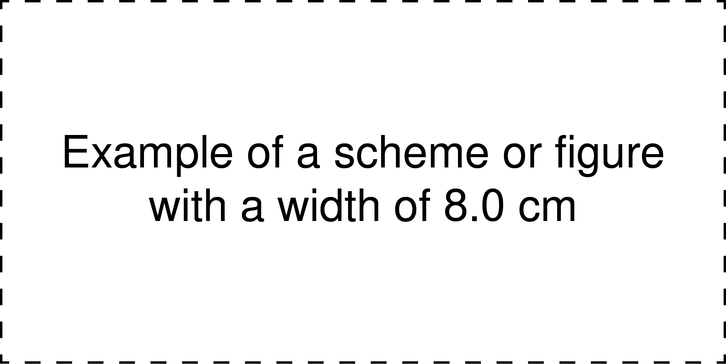

**Figure 1:** Description including labels such as a) and b) to reference distinct parts of the figure.



**Figure 2:** Description including labels such as a) and b) to reference distinct parts of the figure.

**Table 1:** Table titlea.

|  |  |
| --- | --- |
| Example of a table with a width of 8.0 cmb |  |
|  |  |
|  |  |
|  |  |

aTable footnote1; bTable footnote2

**Table 2:** Table titlea.

|  |  |  |  |
| --- | --- | --- | --- |
| Example of a table with a width of 16.0 cmb |  |  |  |
|  |  |  |  |
|  |  |  |  |

aTable footnote1; bTable footnote2

Example of an equation (maximum width of 8.0 cm)

 (1)

and an example of an equation that required splitting (maximum width of 8.0 cm)

 (2)

# Conclusion

Conclusion text

# Experimental (optional)

Experimental text

# Supporting Information (if any)

Supporting information text

Supporting Information File 1:

File Name: Text

File Format: Text

Title: Text

Supporting Information File 2:

File Name: Text

File Format: Text

Title: Text

# Acknowledgements (optional)

Acknowledgement text

# Funding (optional)

Funding text

# References

1. Author1, X. Y.; Author2, X. Y.; Author3, X. Y. *Journal Title,* **Year,** *Volume,* Page Begin–Page End.

2. Author1, X. Y.; Author2, X. Y.; Author3, X. Y. *Journal Title,* **Year,** in press.

etc.